***ASSIGNMENT 1- DAA***

**Name: Ayush Kumar  
Roll No.: 212  
PRN: 0120180560  
Division: D (IT)**

Code:

#include<bits/stdc++.h>

#include <cstdlib>

#include <ctime>

#include <chrono>

using namespace std;

using namespace std::chrono;

long int binary_search(long int arr[],int minm, int maxm,int num)

{

int mid;

if (maxm >= minm) {

mid = (minm + maxm)/2;

if (arr[mid] == num)

cout<<"Your search result find at position No. :"<< mid;

else if (arr[mid] > num){

return binary_search(arr, minm, mid - 1, num);}

else

return binary_search(arr, mid + 1, maxm, num);

}

else

cout<<"\nSearch Not Found";

}

void linear_search(long int arr[],int n,int num)

{

for (int i = 0; i < n; i++)

{

if (arr[i] == num)

{

cout<<"\nYour search result found at position No. : "<< i;

}

}

}

int main(){

int minm,maxm,n,num;

long int arr[100000];

srand(time(0));

n = 100000;

for( int i=0; i<n; i++)

{

arr[i] = i+1;

}

minm = 0;

maxm = n;

num = (rand() % 100000 + 1);

auto start = high_resolution_clock::now();

binary_search(arr,minm,maxm,num);

auto stop = high_resolution_clock::now();

auto duration = duration_cast<microseconds>(stop - start);

cout << "\nTime taken by Binary Search: "<< duration.count() << " microseconds" << endl;

auto startL = high_resolution_clock::now();

linear_search(arr,n,num);

auto stopL = high_resolution_clock::now();

auto durationL = duration_cast<microseconds>(stopL - startL);

cout << "\n\nTime taken by Linear Search: "<< durationL.count() << " microseconds" << endl;

return 0;

}

OUTPUT

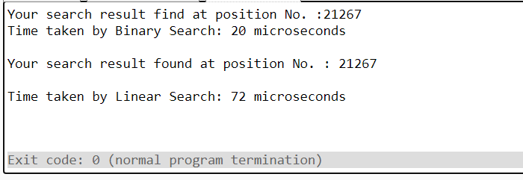

|  |  |  |
| --- | --- | --- |
| Value | BInarySearch (µs) | LinearSearch (µs) |
| 49541 | 33 | 165 |
| 57832 | 27 | 80 |
| 67529 | 34 | 160 |
| 81593 | 34 | 127 |
| 47951 | 34 | 131 |
| 87213 | 37 | 127 |
| 10146 | 21 | 73 |
| 65548 | 44 | 170 |
| 85747 | 33 | 162 |
| 57773 | 31 | 126 |
| 58647 | 32 | 127 |
| 96650 | 21 | 73 |
| 65532 | 33 | 143 |
| 26126 | 33 | 165 |
| 15005 | 38 | 126 |

Graph for above table: